1

Computational Thinking in Music Courses:
How To Get Artsy Types to Start Thinking Like Geeks and Vice Versa

What Is Computational Thinking?
Jeannette Wing coined the term “computational thinking” in 2006 [16] to characterize analytical thought processes that are subject-matter independent. She wrote:
Computational thinking involves solving problems, designing systems, and understanding human behavior, by drawing on the concepts fundamental to computer science. Computational thinking includes a range of mental tools that reflect the breadth of the field of computer science.
While the “mental tools” of which Wing speaks may originate in — or at least be most visible in — computer science, she stresses that “computational thinking is a fundamental skill for everyone, not just for computer scientists.” We wholeheartedly agree. Too often we see students attack problems in a hodgepodge manner, devoid of planning, hoping that trial and error will eventually lead them to a solution. And when they are lucky enough to arrive at a desired result through random processes, students too often fail to understand why a particular approach worked. This makes it impossible for them to generalize the approach and apply it to related problems.
Analytical skills are the essence of computational thinking, and we feel that they are just as important to Music and other Arts majors as they are to Computer Science majors. Both groups are hampered by habit, which limits their abilities to imagine alternative possibilities. By getting students from disparate disciplines to work together, or at least by getting students to look at things from the perspective of someone whose discipline is different from their own, we aim to break the bonds of those habits and help students learn to think analytically. The desired result is a populace that not only knows how to solve problems and design systems, but that also possesses the “mental tools” to do so across a wide scope of problems. Unfortunately, the path to achieving that desired result is anything but clear. As suggested by Sawyer [2], “Innovation can’t be planned, it can’t be predicted, it has to be allowed to emerge” (p. 25).

Operationalizing Computational Thinking
It’s one thing to embrace the concept of computational thinking (CT), but it’s quite another to try to put it into practice. How can we demonstrate CT in action? How can we teach non-science majors to think analytically? What activities can we assign to help them discover and hone CT skills?
These questions are difficult to answer. They have been discussed and debated hotly in articles, at conferences, and on listservs and weblogs (blogs). Google has attempted to provide “classroom-ready lessons and examples showing how educators can incorporate CT into the K-12 curriculum,” but browsing these shows that they are all programming-related [4]. This is not surprising, given that Google defines CT as “a set of problem-solving skills and techniques that software engineers use to write programs that underlie the computer applications you use such as search, email, and maps” [5]. We feel that this definition is a bit narrow and would expand it to include what others call “algorithmic” or “analytical” thinking [9], but there is little agreement in the educational community on the nuances of differences between these terms.
Even Mark Guzdial, the prolific author of arguably the most widely read and certainly one of the most erudite and respected weblogs on computing education, admits that he is “as confused as anyone else [about] what ‘Computational Thinking’ means” [6]. In his post dated August 12, 2010, Guzdial related two experiences that “highlighted ... one aspect of CT ... which I feel is really computational thinking” [emphasis in original]. Both experiences involved looking at data: one his own record of distances run each day in an attempt to correlate that with the timing of injuries sustained, and the other graphs of Atlanta temperatures to substantiate or refute a reporter’s claim that the past summer had been Atlanta’s “hottest in 30 years.” However, even these relatively straightforward examples generated numerous reader comments expressing wide disagreement as to whether they really demonstrated CT, and even more disagreement as to what constitutes CT itself. Here are two of those comments, edited for brevity.
Kevin Karplus (blogging as “gasstationwithoutpumps,” actual name revealed with permission), a professor of biomolecular engineering at the Univ. of California Santa Cruz:
I agree with you that getting lots of data is the heart of computational science, but I don’t think that it is the “computational thinking” part. The analysis of the data is the CT. ... I distinguish between computational and algorithmic thinking. Algorithmic thinking concentrates on the method, the steps of the method, how things are done, [etc.]. Computational thinking relies on the existence of algorithms, but does not care much about how they work. Karplus posted more extensive definitions and a discussion of their distinctions in his own blog (gasstationwithoutpumps.wordpress.com), where he states: Algorithmic thinking is thinking about how to accomplish a particular end. ... Computational thinking is thinking about data by using computers to summarize, massage, or transform data into a more easily understood form. [9]
Fred C. Martin, a professor of computer science at the Univ. of Massachusetts Lowell:
I think this is great example of scientific thinking, and of working with data ..., but I don’t think it has much to do with CT. Martin went on to provide his own example and concluded with: I do think this algorithm is a good example of CT outside of a programming context. Guzdial replied: I completely agree that your example is CT, but I don’t see what criteria you’re applying such that my example is not CT. ... What are the criteria by which we decide what is CT and what is not? Martin replied: I think you hit [the nail] on the head with your question. ... I suppose there are various levels or categories, and really what we’re after are lots of real-life examples of CT — especially, in non-programming domains — and then we can go about seeing how they relate.
Martin’s point is exactly what we try to do in this book. Some of our examples may demonstrate CT and some algorithmic thinking (using Karplus’s definitions [9]), but we don’t think that the distinction is particularly important in this context. What is important to us as teachers of CT through interdisciplinary courses is that we get students to start thinking logically and critically, using data and algorithms rather than only trial and error to implement solutions that extend their creativity. We do not mean to minimize the value of trial and error, which is an important pathway into the discovery process. We merely wish to emphasize the importance of helping students think more analytically and systematically about processes and the progression of their ideas and actions.

A First Activity to Introduce CT
Here’s a fun way to introduce CT in class. Begin by telling students that they’re going to write down the series of steps — an algorithm — for making a cup of tea, given that they have an empty tea pot, a source of water, a working stove, a tea bag, and a tea cup. They’ll quickly give you a sequence similar to this:
- Fill the tea pot with water.
- Put the pot full of water on the stove.
- Turn the stove on.
- Wait for the water to boil.
- Turn the stove off.
- Pour the boiling water into the cup.
- Put the tea bag into the cup.
- Wait until the tea is a strong as you like it
- Remove the tea bag.
Of course there can be variations. Some students may want to interchange steps 6 and 7, and some may want to include steps for adding sugar or lemon or milk. That’s fine. But it shouldn’t take long to hone in on a series of steps that the entire class can support.
You’ve now got an algorithmic solution to the original problem. Now tell the students that you want them to solve the same problem, but that they are to begin with a pot full of boiling water. Tell them that if they think of the algorithm they just developed as an atomic piece of data, it’s actually possible to solve the problem in just two steps!
Most students will understandably claim that the solution is to skip the first five steps of the original algorithm and complete steps 6-9. But that’s four steps, not two. If one thinks of the entire 9-step algorithm as a single piece of data, the two-step solution is to pour out the boiling water from the tea pot and reduce the second problem to the first, which has already been solved! Performing the algorithm is then a single step, because you know it works and you don’t even have to think about its component steps. CT involves thinking about all aspects of the problem as data.
Students will argue that the two-step solution is inefficient. They will say that it’s crazy to go backwards. But we do such things every day. We have all been in situations where we’ve tried to follow directions and gotten lost and decided that “it’s easier to start over.” In music, when rehearsing and trying to correct errors in a tricky passage, it’s often difficult to start in the middle. It’s more natural to go back to the beginning of a section or phrase, and then rehearse the passage over and over from there. This type of thinking relies on understanding structure, which is the basis of all data analysis, which is in turn the basis of CT.

Computational Thinking in Musical Flowcharts
How might you demonstrate computational (or algorithmic) thinking in a musical context? Building on the above discussion, we suggest that one answer lies in viewing music as data and looking for patterns that we also find in computer programs. In yet another response to Guzdial’s post discussed above, Severance wrote:
I think that the key point of your analysis (which I agree with) is that data is a great place to start with when it comes to developing computational thinking as a skill. Each of the examples you used was not only data, but it was data that was about people and/or something you could touch, feel, and see. ... Computational thinking begins to grow as soon as they start looking at the information methodically...
Can we use music as data? Yes, we can. MIDI, AIFF, WAV, and MusicXML files can all be treated as data, as well as files in the alphabet soup of audio compression formats such as MP3, OGG, M4A, etc. However, analyzing these types of data, particularly at the level of individual samples, is probably way beyond the scope of an introductory course. (Analyzing some of them is not, however, as we will discuss when we talk later about our use of MIDI.) In our work, we have therefore moved up to a higher level of abstraction, that is, to songs themselves.
Can songs be data? Yes, they can. It is easy to imagine a relatively simple computer program built from the wealth of “meta” information stored in MP3 files (see Figure 1-1). Students could create a program that builds a list of all the songs in their own music libraries and then “mine” that data using simple sorting and searching techniques to, for example, find all the songs sung by a given artist, written by a given composer, or recorded before a given date. But that’s not really working with the music, it’s working with the music’s metadata. Such data is information about the song, but not the song itself. If you’re familiar with iTunes®, you might agree that that program has a brilliant, efficient, and user-friendly interface for accessing the contents of one’s music library according to the various musical attributes stored in metadata.
The students we teach find it much more interesting to work with the actual music itself. But where’s the data in that music? One answer: “in the song’s structure.” Music students are familiar with describing song structures with letters, such as ABA and ABACA. But to get into CT, we need them to get more fine-grained. We need to get them to work with the notes themselves, to look for patterns in those notes, and to show their connections. A flowchart lends itself very nicely to this approach and leads directly into programming, as we will see later.
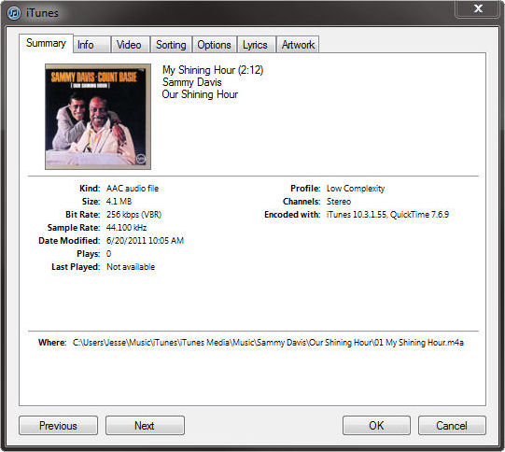
Figure 1-1. Music metadata displayed in iTunes.® [1]
Consider, for example, the flowchart in Figure 1-2. Working with a song’s lyrics is much more interesting than its metadata, and those lyrics are an integral part of — or at least a very reasonable handle on — the music itself. Since not all of our students are fluent with traditional music notation, it’s a bit harder to label flowcharts for music (or parts of songs) that do not have lyrics, but it is not impossible. You just have to figure out some way to refer to each part or musical chunk.
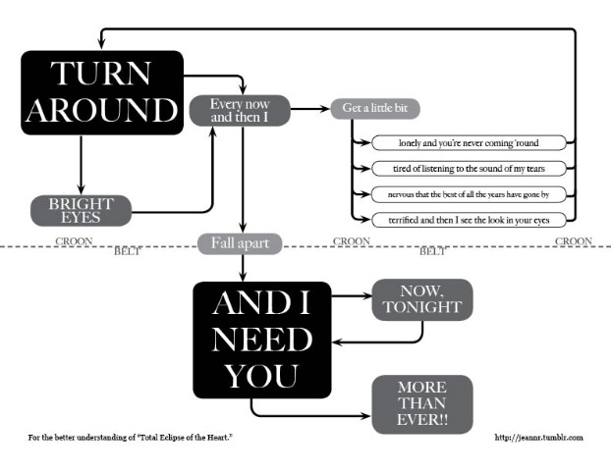
Figure 1-2. A flowchart for the beginning of “Total Eclipse of the Heart”
by Jim Steinman, as recorded by Bonnie Tyler. [7]
Copyright © 2009, Jeannie Harrell. Reproduced with permission.
The beauty of musical flowcharts as an introductory activity or assignment in an interdisciplinary music and computing course is that students don’t need to know anything at all about either music or computing to create them. They don’t even need to know about standard flowchart symbols. All they need to know is how to draw boxes and arrows. Of course, much more sophisticated flowcharts can be created, but the important thing is that every student, regardless of background and discipline, can get fully and immediately engaged with CT without the need for an extensive conceptual lecture or a lot of handholding or scaffolding. As always, the examples presented in this book draw on the domains of music and computing, the focus of our course and this book, but similar activities can be designed that cross disciplinary boundaries and encourage CT by students of all majors.

Chunking and Connecting
Where is the CT in musical flowcharts? We think there are two answers: (a) in the size of the chunks, and (b) in the ways they are connected. The former requires thinking about what constitutes a data item. If the chunks are too large, one can’t see the song’s repetitive patterns. If they’re too small, one loses the essence of the song expressed in its phrasing. The latter requires thinking about process, that is, how the sequencing of the chunks contributes to the song’s message and reinforces its melodic and lyric structures. Using Karplus’s definitions [9], and as discussed earlier, some may classify the former as CT and the latter as AT (algorithmic thinking), but we feel that the distinction is largely academic. Both are equally valuable in helping students develop the “mental tools” that they need to learn to apply to everyday problems.
The goal of the musical flowcharting activity is to have as few blocks as possible, or at least as few different types of blocks as possible. However, we don’t state this goal before we turn students loose on the activity. Rather, we try to get them to discover the advantages of this goal on their own. To do that, we introduce the activity quickly and then let students play around with it. After 15-20 minutes or so, we interrupt them and ask a few students to show their flowcharts to the class (using an opaque projector or document camera). As we lead the discussion of these initial efforts, students often call out comments such as:
- “If you move x into its own box, you wouldn’t have to write it so many times in all those other boxes.”
- “The song doesn’t really go from x to y. You missed part z in there, which is really a distinct part all by itself.”
- “It’s easy to understand two arrows going into a box from different directions, but you’ve got two arrows coming out of box a. One goes from a to b and the other from a to c. How do I know when to follow the first path and when to follow the second?”
Some of these issues can be illustrated by Harrell’s flowchart in Figure 1-2, so we will examine that in a bit more detail.
For this activity, we discovered that students will generally gravitate toward familiar songs that have a great deal of repetition. They also tend to work within a musical genre that resonates with them personally, as the following reflection by one student indicates.
… we worked together to create a flowchart to a song we were all familiar with: Send Me On My Way by Rusted Root. We had all heard the song before, but now [we] realized exactly how much repetition defined the form. When constructing our flowchart, we first paid attention to the lyrics.
Of course the easiest place for students to find song lyrics is online, and there are numerous popular lyric websites of varying quality. Here’s how the lyrics for the beginning of Total Eclipse of the Heart (shown above the dashed line in Figure 1-2) appear on www.sing365.com [13].
(Turn around)
Every now and then
I get a little bit lonely
And you’re never coming round
(Turn around)
Every now and then
I get a little bit tired
Of listening to the sound of my tears

(Turn around)
Every now and then
I get a little bit nervous
That the best of all the years have gone by

(Turn around)
Every now and then
I get a little bit terrified
And then I see the look in your eyes
(Turn around, bright eyes)
Every now and then
I fall apart
etc.
We’ve chosen this particular website because the lyrics are well formatted, making it easy to see the patterns and recognize the repetitions. “Turn around” and “every now and then” clearly repeat multiple times, but it’s in the 5th and 6th repetitions where “bright eyes” gets thrown in between these two and takes the song to a new emotional level. Thus, it’s important that “turn around” and “every now and then” be seen as separate “chunks.” Yet a close listening would reveal that on the 3rd repetition of “Turn around,” the phrase starts a minor third higher, helping to build toward the intensity of the next section. You wouldn’t pick up on this fact just from looking at the flowchart or reading the lyrics. Said differently, it’s hard to see these patterns when one merely looks at the printed lyrics, but it’s easy to hear these patterns and subtle changes when one listens to the song. This is one place where it is beneficial to have students work in interdisciplinary teams, as some wonderful discussions ensue as they help each other to identify the patterns. This was brought out in a comment that a student posted in his blog:
- The flowchart assignment highlighted how much structure and repetition go into music. Immediately after finishing part of my flowchart, it became apparent that there was a very specific structure to the song. My song (Poker Face by Lady Gaga) starts with a musical intro, goes into a verse, then to a pre-chorus and a chorus, then back to another verse. ... The structural knowledge that I gained by completing this assignment helps explain how loops, if statements, and broadcasts will be used successfully to create interesting music. We will basically be able to recreate flowcharts of our own songs using the Scratch blocks.
In mathematical terms, getting to as few blocks as possible is known as factoring. That is, one factors out the common elements and isolates them into separate boxes. This is precisely what programmers do when they write functions and subroutines: they take chunks of code that are repeated at various points in a program and isolate them into their own named blocks so that they can be “called” whenever needed. There are many benefits to organizing code in this manner.
- The code is clearer, making it easier to understand.
- The code is smaller, making it not only more manageable for humans, but also more efficient for computers to execute.
- If a bug is found, fixing it once fixes it everywhere that block of code is called.
- If the block is written well and in a generalized manner, it may be possible to use that function or subroutine in other programs without any changes at all, saving huge amounts of development and debugging time.
Thus, the analysis of songs through their lyrics and the “chunking” of those lyrics into the repeatable elements are clearly CT skills, as they have direct application in computer programming. As noted earlier, we don’t think that all CT skills have to have direct analogies in programming, but this one does. Later we will see how these skills can be applied and practiced by programming mash-ups created from actual song chunks.
Once we have our chunks, the next step is to connect them up. Here’s where the flowchart in Figure 1-2 has a problem: when should one follow the path from “turn around” to “every now and then I,” and when the path from “turn around” to “bright eyes?” Likewise, when should one follow the path from “every now and then I” to “get a little bit,” and when the path from “every now and then I” to “fall apart?” Harrell’s flowchart doesn’t help us here. This can be solved by introducing numbers to indicate order when there are multiple possible paths. Given the layout of the flowchart, numbers don’t seem necessary to indicate the order of the four phrases that follow “get a little bit,” but we will see that even in that sequence there are numbers involved even if they’re implicit.
Flowchart aficionados may wish to add diamond-shaped if blocks to Harrell’s flowchart, and that would be fine, but simply getting students to add numbers as shown in Figure 1-3 in this situation suffices for us.
Figure 1-3. Harrell’s flowchart with numbers added to clarify flow.

The numbering may seem obvious to some, but it is not at all obvious to others, because after you visit ❸ you have to go back to ❶. The key here is to number the blocks such that (a) you must follow the arrows, and (b) you must visit every number before following a path to the next higher number, although you can visit numbers you’ve already visited any number of times. Thus, the paths through this flowchart are:
 [This is font CombiNumbers Bold from
http://www.fontspace.com/category/numbers,circles]





There are many CT concepts here. Numbers. Counters. Loops. Incrementing. Conditionals. And even an algorithm. Returning to the geeky definition of CT on Google’s website [5], we see that they list “decomposition,” “pattern recognition,” “pattern generalization and abstraction,” and “algorithm design” as specific techniques that are examples of CT. All of these techniques can be introduced using musical flowcharts.
While these concepts may seem simple to those of us who have already grasped them, to some students they are anything but. The real killer is trying to teach the meaning of incrementing to non-programmers, especially using a statement such as:
counter = counter + 1
That’s probably the most commonly used statement in all of programming, yet it can be a real hurdle for non-science majors to get over. Even the seemingly obvious Scratch version of this statement can throw them:
A musical flowchart can give them the conceptual boost they need to clear that hurdle.
For example, most students can follow Harrell’s flowchart intuitively without needing a lengthy explanation. But when we talk about writing a program to actually play the song, things quickly get complicated. To connect the song flowchart to a computer algorithm and take the next step in computational thinking, we introduce the concept of a counter for the path (arrow line) to follow. The logic then works like this:
- initialize (set) the path counter to 0
- play the chunk that follows the current value of the path counter
- increment (add 1 to) the path counter
- follow as few paths as possible to get to the path now in the path counter, replaying chunks previously played along those paths
- go back to step 2
There are, of course, no right and wrong ways to create musical flowcharts. Getting it “right” is not the point. Rather, the point is to get students to look at their world in a new way and, through music, to begin to think analytically and algorithmically. These aspects of CT are applicable in music as well as in computing, for if one understands a song’s structure, it is easier to perform it with appropriate dynamics, expression, and emotion, or to interpret it in one’s own way through variation or improvisation.
Added bonus #1 is that students start to see that music can be represented in something other than its standard form, which pays benefits in other interdisciplinary activities that we discuss in later chapters. One student commented on the benefit of this “new” way of representing music as follows.
The first song that came to my mind was “Stairway to Heaven” by Led Zeppelin. This song is notorious in the musical world (particularly to guitarists) for having phrases that cycle and then change. This makes for an ideal candidate for a flowchart ... As I never would have thought, this project allowed me to become even more fascinated with this legendary song. Mapping a song’s progression not only lets you visualize the sequence of events, but forces you to truly listen to what’s happening. I’m glad this was our song of choice because I had to replay this song at least ten times before the final chart was completed. And that was fine by me!
Added bonus #2 is that students work with music of their own choice, thereby maintaining interest. Added bonus #3 is that the chunks resulting from this work fit perfectly into future activities and assignments where we ask students to create new compositions from pieces of existing songs. This last bonus is underscored by a comment from one of the CS students in the class:
As a computer science major, I was able to view the flowchart as a “computer program” as well. I was able to find various programming constructs such as looping and conditionals within the flowchart. This has helped out quite a bit with this assignment because I was able to use the chart to splice up my song. ... Through this assignment, I learned to view musical structure in terms of programming. A lot of the concepts in our flowchart could easily be modeled via programming constructs such as loops and conditionals. I learned that I could essentially “block out” parts of the song into their own respective sections, then connect them via some kind of bridge. This is just like executing different blocks of code based on a condition. Having the flowchart made it much easier to see these internal structures, which will come in very handy when trying to unroll the song into Scratch code.
When we grade this assignment, we look, as always, for effort and creativity, but we also look specifically for elegance. That is, we look for flowcharts that are neat and clean and easy to follow, as well as those that have chunks that are truly indivisible “atoms” of the song. We consider how well students do at chunking the music to its most basic level, handle the song repetitions in a logical intuitive manner, understand the inherent structural hierarchy of the music, and represent the serial and parallel elements of the music.
The same characteristics define quality computer programs, the development of which we see as just as creative an endeavor as composing a piece of music. Thus, we believe that these exercises have real benefits for computer science majors as well as students in the non-sciences. When one gets beyond the restrictions of computer language syntax and grammar, programmers engage in a truly creative activity in which they craft elegant solutions to interesting problems. We see that as completely analogous to what musicians do when they create and perform music after mastering the building blocks of music and the mechanics of their instruments.

Student Examples
Student Jenna Hoy created the flowchart in Figure 1-4 for John Lennon’s All You Need Is Love as performed by the Beatles and released in the US on Magical Mystery Tour. Jenna used simple boxes and lines, but added color to differentiate sections of the song and add interest. We were delighted to see that she made the first “Love” block a heart rather than just a simple block. The rendering isn’t perfect, but it clearly shows an understanding of the song elements and how they fit together.
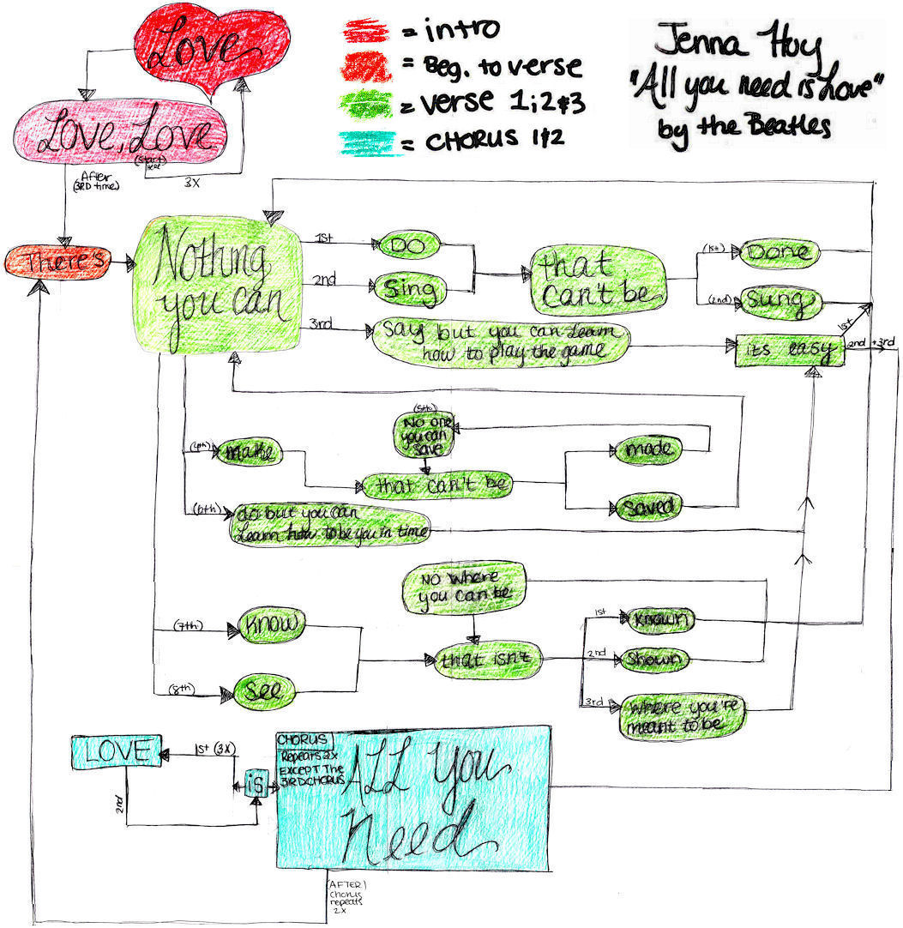
Figure 1-4. Student Jenna Hoy’s flowchart of the Beatles’
All You Need Is Love.
Another excellent effort came from student Josh Ragucci, shown in Figure 1-5. This one is missing some words and needs arrowheads, but it succeeds at capturing the essence of the song’s flow.
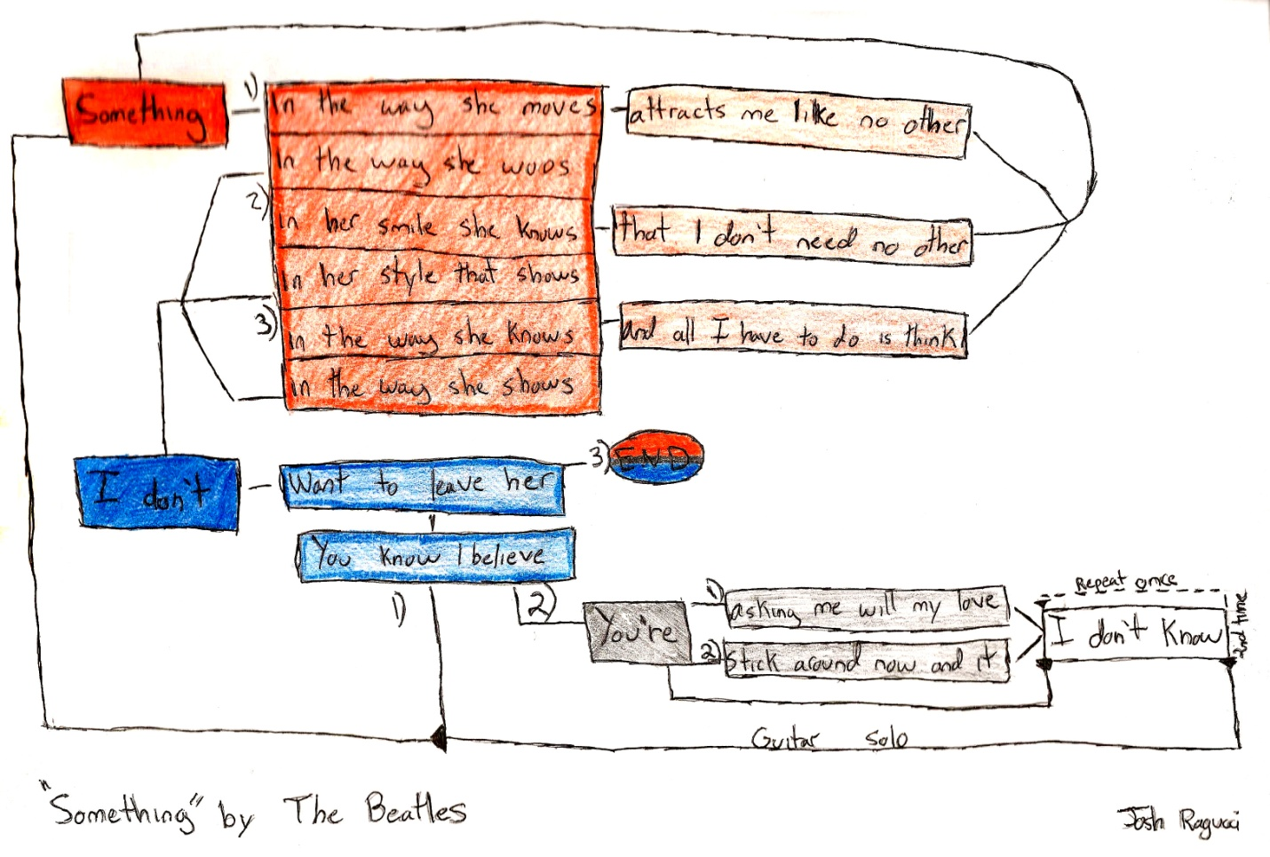
Figure 1-5. Student Josh Ragucci’s flowchart of the Beatles’
Something in the Way She Moves.
Another approach is illustrated by the submission from student Kevin Webb in Figure 1-6. This flowchart also has some musical flaws and lacks arrowheads, but it illustrates what can be done using readily available software tools. Some of those tools are expensive, but others are freely available on the web. What’s most surprising is that one of the easiest to use flowchart drawing program is probably already installed on your own system!
Figure 1-6. Student Kevin Webb’s flowchart of the Beatles’
Maxwell’s Silver Hammer.
It just so happens that the ubiquitous Microsoft Office products have quite sophisticated tools for drawing flowcharts already built-in, and most students can use these with little to no introduction. They work especially well in Microsoft PowerPoint, perhaps because that program is more oriented toward working with shapes and lines than the other Office products, such as Word or Excel. For Mac users, many of our students found Keynote equally well suited for this assignment. The really cool thing about these tools is that once you connect two shapes with an arrow anchored to the shapes’ side or corner “handles,” you can move those shapes and the connector automatically adjusts its position to keep the arrow connected (see Figure 1-7). This saves a lot of time in laying out flowcharts.
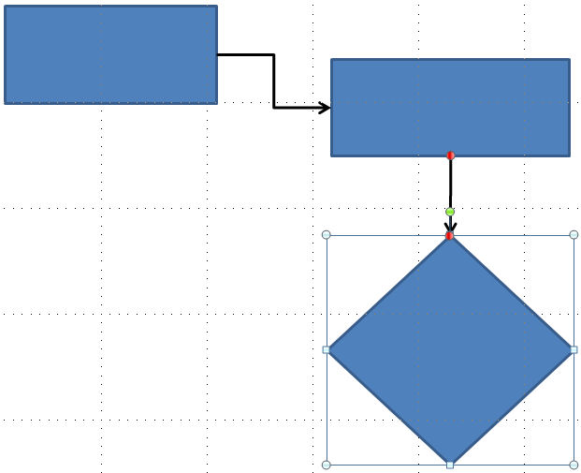
Figure 1-7. Shapes and connectors in Microsoft PowerPoint 2007.
A free, web-based program that a number of our students have found easy to use is at flowchart.com [3], shown in Figure 1-8. In addition to providing terrific templates to get you started, an excellent editor, a wealth of clipart you can add to your flowchart, the ability to export your work in to Adobe PDF format, and numerous advanced features, flowchart.com provides a place to store templates and the ability to share them with others.
Figure 1-8. Flowchart.com editor. [3]

Looking Ahead
These examples should give you a pretty good feel for how we teach CT using music, and hopefully “prime the pump” of your own thoughts for developing similar activities or adapting ours for use in your courses. There are many more examples to come. The next chapter describes how we get students started even before we do the flowchart assignment and presents more of our approach in context.

Bibliography for Chapter 0
[1] Apple, Inc. (2011). iTunes (ver. 10.3.1.55).
[2] Berlin, I. (1946). Annie Get Your Gun.
[3] Flowchart Software (2011). Online flow charts software service with realtime collaboration. (Version 2.4-r11, updated 2011/06/10 03:07 UTC.) flowchart.com accessed 6/12/2011.
[4] Google (2011). Exploring Computational Thinking: Lessons and Examples. www.google.com/edu/ computational-thinking/lessons.html accessed 6/3/2011.
[5] Google (2011). Exploring Computational Thinking. www.google.com/edu/computational-thinking accessed 6/3/2011.
[6] Guzdial, M. (2010). Go to the Data: Two stories of (really) Computational Thinking. Computing Education Blog. computinged.wordpress.com/2010/08/12/go-to-the-data-two-stories-of-really-computational-thinking accessed 6/2/2011.
[7] Harrell, J. (2009). Koufukuron ("On Joy"). jeannr.tumblr.com/post/165291081/i-made-a-flow-chart-that-we-might-better accessed 12/25/2009, reproduced courtesy of the author.
[8] Hetland, L., Winner, E., Veenema, S., & Sheridan, K.M. (2007). Studio Thinking: The Real Benefits of Visual Arts Education. New York: Teachers College Press.
[9] Karplus, K. (2010). Algorithmic vs. Computational Thinking. "Gas station without pumps" blog. gasstationwithoutpumps.wordpress.com/2010/08/12/algorithmic-vs-computational-thinking accessed 6/3/2011.
[10] MIT Scratch Team (2009). Scratch. scratch.mit.edu accessed 12/21/2009.
[11] Resnick, M., Maloney, J., Monroyhernández, A., Rusk, N., Eastmond, E., Brennan, K., Millner, A., Rosenbaum, E., Silver, J., Silverman, B., & Kafai, Y. (2009). Scratch Programming for All. Comm. of the ACM 52(11):60-67.
[12] Ruthmann, S.A. (2009). Computational Zeppelin. scratch.mit.edu/projects/alexruthmann/736779 accessed 1/5/2010.
[13] Steinman, J. (1983). Bonnie Tyler "Total Eclipse of the Heart" Lyrics. www.sing365.com/music/ lyric.nsf/total-eclipse-of-the-heart-lyrics-bonnie-tyler/fb0f584f5cd507a4482569910025c3c1 accessed 6/12/2011.
[14] Univ. of Massachusetts Lowell (2011). General Education Program. www.uml.edu/gened/index.html accessed 6/14/2011.
[15] Univ. of Massachusetts Lowell (2011). Courses Approved for General Education 2000 Program. www.uml.edu/gened/courses.html accessed 6/14/2011.
[16] Wing, J.M. (2009). Computational Thinking. Jrnl. of Computing Sciences in Colleges 24(6):6–7.
[17] Yanco, H.A., Kim, H.J., Martin, F.G., & Silka, L. (2007). Artbotics: Combining Art and Robotics to Broaden Participation in Computing. AAAI Spring Symposium on Robots and Robot Venues: Resources for AI Education. Stanford, CA.

Musical Instrument Digital Interface file format, which associates each semitone note with a number.
Audio Interchange File Format, which is popular on Macintosh systems.
WAVeform audio file format, which is popular on Windows systems.
A music-specific eXtensible Markup Language (XML), which is supported by numerous systems.
“Loops, if statements, and broadcasts” are all components of the Scratch programming environment, a media-rich visual programming system developed by the Lifelong Kindergarten Group at the Massachusetts Institute of Technology Media Lab. We use Scratch throughout our interdisciplinary Sound Thinking course, and it is freely downloadable from scratch.mit.edu. We discuss Scratch and how we use it more extensively later, but we think you will be able to grasp the essence of the examples in this chapter without a formal introduction. Many of our examples of student work were built using Scratch.
It is not a coincidence that both of these flowcharts depict songs by the Beatles, as so many of our students chose to work with music by that iconic group. We find that fascinating, especially when we remind ourselves that none of these young people were even alive in 1980 when John Lennon was killed.

